DC Capacitor and Battery based Voltage Balancing Control for Cascaded H-Bridge STATCOM with Edmonds’ Algorithm

S. Kavya, PG Student

Department of Electrical and Electronics Engineering

Vivekanandha College of Engineering for Women

Tiruchengode, India

kavyaeee12@gamil.com

S. Anurekha, PG Student

Department of Electrical and Electronics Engineering

Vivekanandha College of Engineering for Women

Tiruchengode, India

anurekhaias1995@gmail.com

Mr. S. Mutharasu, M.E., Assistant Professor

Department of Electrical and Electronics Engineering

Vivekanandha College of Engineering for Women

Tiruchengode, India

mutharasu@vcew.ac.in

*Abstract*—This project deals with enhancing the voltage quality from voltage sags and one more power quality issues are rectifying in this project that is a harmonics. The level of the inverter is increased for accurate system performance. The system has more stable by proposed Edmonds’ algorithm and its used for finding a spanning dendriform of minimum weight (sometimes called optimum branching). Its an directed analog of the minimum spanning tree problem. This algorithm is faster implementation and less number of iterations compared with other algorithms. This algorithm to produce a delta signal for controlling the space vector pulse width modulation signal because the SVPWM has only produce in the static frequency so lightly harmonics are produced so the quality of the power is reduced. That harmonics are reduced by using the variable frequency is produced by algorithm. The STATCOM is used in fifteen level inverters for better performance its reduce a generation of harmonics and it get a dc sources from capacitor banks and battery banks because this store a huge amount of energy compared with capacitor banks. A simulation model based on this method is built in the MATLAB platform. The simulation results show that, the proposed control algorithm can make sure STATCOM precisely and quickly compensate reactive power, improve the power factor, stabilize the DC voltage and compensate the voltage sag and reduce the generation of harmonics.

Keywords—static synchronous compensator(STATCOM); cascaded h-bridge converter (CHB); space vector modulation(SVM); leg balancing; cluster balancing; battery bank; load unbalance; grid unbalance; Edmonds algorithm

# **I. Introduction**

W

ith the developments and popularity of power electronics technology, numerous and diverse electrical machinery and apparatus based on power electronics are increased rapidly. However, due to the nonlinear operating characteristics of power electronic devices themselves the system based on power electronics might results in power quality problems on utility grid. Especially, with single-phase AC traction system and electrical arc furnaces, the voltage flicker has been considered as one of the most severe power quality problems such as harmonic distortion, poor power factor, and phase imbalances to the utility grid. These power quality problems lead to unexpected disturbances in normal operation of electric facilities which share the same distortion feeder with these aforementioned nonlinear loads, poor power factor, and unbalanced loads is one of the most important issues in power systems [1-2]. Many technologies have been devised and proposed to improve the grid power quality and to resolve the imbalance of loads. The static synchronous compensator (STATCOM) is one of the technologies developed. The STATCOM, emulating variable voltage source converter (VSC), can provide precise reactive power, and it could mitigate the disturbances and improve the power quality effectively [2-4].

The response time of STATCOM is more rapidly than that of a static VAR compensator (SVC), mainly due to the fast switching frequency provided by the power switches based on high-power forced-commutated semiconductors such as IGBT, IGCT, IEGT, etc. Among VSC-STATCOMs, the multilevel converter based STATCOMs is an advanced alternative to the conventional two-level VSC-STATCOM. The conventional STATCOM is composed basically of one VSC with a capacitor in the DC side and a coupling transformer in the AC side. However, the multilevel converter has more cost-effective and better performance than the conventional converter due to unnecessary bulky coupling transformer, extended power rating, many voltage levels suitable for medium- or high-voltage high power application, and so on. The cascaded H-bridge (CHB) converter is one of the most feasible topology for multilevel STATCOM applications since it has advantages such as modular structure for easy scalability, fast response and enhanced output current waveform [5-7].

The submodule cell in the cascaded H-bridge converter for STATCOM is composed of an H-bridge converter and a DC capacitor. As the DC capacitor in submodule cell cannot operate with the constant DC source, the DC capacitor voltage fluctuates according to various operation condition of CHB converter. And, the technologies of switching pattern and modulation have been widely studied for system stability based on CHB converter [8]. Furthermore, even under unbalanced AC voltage and unbalanced load conditions, the equilibrium among the DC capacitor voltages should be guaranteed to compensate the reactive power and voltage at the point to common coupling (PCC). Therefore, the balancing control to maintain DC capacitor voltage and reduce voltage ripple is indispensable part for the stable CHB converter controls [9-10].

In this paper a novel control strategy has been proposed and verified for delta-connected CHB converter based STATCOM under unbalanced PCC voltage as well as unbalanced load compensation. The control strategy can balance the DC capacitor voltages of each cell considering voltage imbalances of PCC. Furthermore, a novel feedforward control algorithm which directly calculates zero-sequence circulating current for system balancing is proposed. This paper employs the real-time calculation of the instantaneous AC leg output voltages and leg currents and thus dynamics could be enhanced. Therefore, the proposed feedforward calculation algorithm based on vector analysis improves the system dynamics conspicuously. To demonstrate the complete verification of the proposed method, a mathematical proof is included.

# Phase 2 block diagram.png

## Fig. 1 Block Diagram for Proposed System

Fig. 1 is a block diagram of proposed system. It consists of blocks following as below;

* Utility grid
* Nonlinear load
* CHB converter
* STATCOM
* Capacitor bank
* Battery bank
* IGBT switch
* PWM Generator
* PID controller
* Edmonds’ Algorithm

The above Fig. 1 is the overall functions are following as, the generation station power is generated that power is transferred to the load side through the grid. That power is transfer in the middle of the time such faults are occur in the grid lines so, the quality of the grid power is reduced by that faults. If voltage sags is occur how to compensate that faults so, this algorithm is proposed.

The PID controller has some set of reference values for simultaneously monitoring or measuring the capacitor bank values. If capacitor bank is suddenly down that compared with set of reference values of the PID controller and disenabled the capacitor bank and enabled to the battery bank to the CHB inverter through the IGBT switch. The PID controller has two inputs one is set of reference values and another one is DC capacitor bank values. Then next PWM Generator is produced a space vector pulse width modulation signals. It has taken the two inputs one is ac grid voltage and another one is capacitor bank reference voltage. PID controller is identify if any errors are available that errors are given to the PWM Generator for input and its produces a gate pulses for cascaded h-bridge inverter switching operations. The PWM Generator produces a static frequency so, some changes are not modified in voltage then harmonics are generated in the output of an inverter. The Edmonds’ algorithm is proposed for controlling purposes of gate pulses then gate pulses are controlled and variable frequency are produced and its given to the input in cascaded h-bridge switches and CHB inverter has two inputs one is gate pulse and another one is capacitor bank is discharged energy to the CHB inverter. That CHB inverter has inverting the dc voltage to the ac voltages. Those voltages are injected to the grid lines used in the STATCOM. Finally, the voltage sags are compensated using this control technique.

## A. Design and working principle of STATCOM

Static Synchronous Compensator (STATCOM) is the second generation of FACTS controllers that has very promising future application. This is a power electronic device using force commutated devices like IGBT, GTO etc. To control reactive power flow through a power network and there by increasing the stability of power network. STATCOM is also known as a Static Synchronous Condenser (STATCON). The terms Synchronous in STATCOM mean that it can either absorb or generate reactive power in synchronization with the demand to stabilize the voltage of the power network. And it has several advantages of being small/compact, high response speed and no harmonic pollution. The world’s first commercial STATCOM (±80 MVA, 154kV) was developed by Mitsubishi Electric Power Products, Inc and was installed at Inuyama Substation in Japan in 1991. One of the many devices under the FACTS family, a STATCOM is a regulating device which can be used to regulate the flow of reactive power in the system independent of other system parameters.

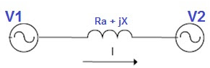

To understand the working principle of STATCOM, we will first have look at the reactive power equation. Let us consider two sources V1 and V2 are connected through impedance Z = R + jX as shown in figure above. The above flow of equation is an reactive power

Where, δ 🡪 is the angle between V1 and V2.

Thus if we maintain angle δ = 0 then Reactive power flow will become $Q=\left(\frac{V2}{X}\right)(V1-V2)$ 
 (1)

And active power flow will become

$P=V1V2 \sin{\frac{δ}{X}=0}$ (2)

To summarize, we can say that if the angle between V1 and V2 is zero, the flow of active power becomes zero and the flow of reactive power depends on (V1 – V2). Thus for flow of reactive power there are two possibilities.

* If the magnitude of V1 is more than V2, then reactive power will flow from source V1 to V2.
* If the magnitude of V2 is more than V1, reactive power will flow from source V2 to V1.

## B. Cascaded h-bridge inverters

The cascaded h-bridge multilevel inverter is to use capacitors and switches and requires less number of components in each level. This topology consists of series of power conversion cells and power can be easily scaled. The combination of capacitors and switches pair is called an H-bridge and gives the separate input DC voltage for each H-bridge. It consists of H-bridge cells and each cell can provide the three different voltages like zero, positive DC and negative DC voltages. One of the advantages of this type of multilevel inverter is that it needs less number of components compared with diode clamped and flying capacitor inverters. The price and weight of the inverter are less than those of the two inverters. Soft-switching is possible by the some of the new switching methods.

This inverter uses several H-bridge inverters connected in series to provide a sinusoidal output voltage. Each cell contains one H-bridge and the output voltage generated by this multilevel inverter is actually the sum of all the voltages generated by each cell i.e. if there are k cells in a H-bridge multilevel inverter then number of output voltage levels will be 2k+1.

Circuit configuration of a general cascaded H-bridge Thirteen Level Inverter is shown in Fig. 2. Each H-bridge module has an independent DC voltage source of E. Every output terminal of H-bridge cells is connected in series. So the output voltage can be obtained by equation (3). And the number of output voltage levels is obtained by equation (4).

$Vout= \sum_{n=1}^{k}{Vn=V1+V2+V3+}V4$ (3)

N = 2k + 1 (4)

In Equation (3), Vin can be E, 0, or –E therefore, Vout can produce -4E, -3E, -2E, -E, 0, E, 2E, 3E, 4E by mixing of each output voltage. We can notice that this kind of Multilevel Inverter is advantageous in terms of modularity and simplicity. However, it needs a 16 switches for single phase at the same time three phase it’s needs a 48 switches and it’s needs a independent DC input sources to produce nine output voltage levels.

## C. Space Vector Pulse Width Modulation

The Space Vector Modulation (SVM) PWM technique, there is repeat switching between each cell only relates to one device switching, so the switch consumption is small. Using the voltage space vector to generate the three phase PWM wave directly to simplify calculation. The inverter output line voltage fundamental maximum value is the Dc side voltage, which is 15% higher than the output voltage of common SPWM inverter.

There are huge principle and source difference between SVPWM (space vector pulse width modulation technique) and SPWM, but they are also some common things for them. SPWM is modulated by sine wave and triangular wave, while SVPWM is modulated by triangular wave and since basic wave that contains certain third harmonic content, which can be proved mathematically.

## D. Edmonds’ Algorithm

The proposed algorithm is an algorithm for finding a spanning arborescence of minimum weight (sometimes called an optimum branching). It is the directed analog of the minimum spanning tree problem. The algorithm takes as input a directed graph D=<V, E>

Where, V = is the set of nodes

E= is the set of directed edges

The weight of arborescence is defined to be the sum of its edge weights,



The algorithm has a recursive description. Let,



Denote the function which returns a spanning arborescence rooted at of minimum weight. We first remove any edge from E whose destination is τ . We may also replace any set of parallel edges (edges between the same pair of vertices in the same direction) by a single edge with weight equal to the minimum of the weights of these parallel edges.

Now, for each node v other than the root, find the edge incoming to v of lowest weight.





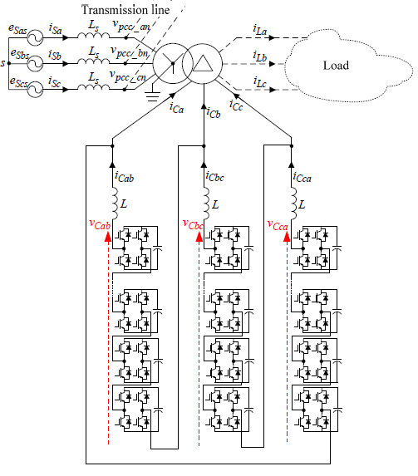

Fig. 2 System configuration of delta-connected CHB converter for STATCOM

## D. The Overall controls in the configurations

* Circuit Configurations of Delta-connected CHB converter
* Output Current Control and Total Energy Control
* Leg Energy Balancing Control
* Voltage Control of Individual Submodule DC Capacitor

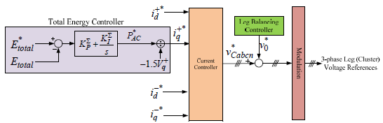

Fig. 3 Overall control scheme of STATCOM

## E. Circuit Configurations of Delta-connected CHB Converter

Fig. 2 shows one example of the circuit configurations of delta-connected CHB converter for STATCOM systems. The system consists of a delta-connected CHB converter and a coupling transformer in parallel to transmission line. The CHB converter is composed of series-connected identical submodule cells and interface inductors (L). Basically, control of the reactive power is possible by variation of the magnitude and phase of the output voltage with respect to PCC voltage (Vpcc-abcn). And, the STATCOM can operate in inductive or capacitive mode.

## F. Output Current Control and Total Energy Control

The overall control diagram of the STATCOM system is depicted in Fig. 3, and the controller consists of several control parts. Among them, the output current controller and total energy controller are the most fundamental controllers. In this paper, the active current is aligned to positive-sequence q-axis, and the reactive current is aligned to positive-sequence d-axis in synchronous reference frame. The positive-sequence q-axis current is utilized for the total energy control of all DC capacitors in CHB converter. And, the positive-sequence d-axis current provides the required reactive power. The negative-sequence d- and q-axis current is utilized for other purposes such as reactive power control under unbalanced grid and load conditions, PCC voltage control for improving voltage quality, grid current conditioning, and so on.

## G. Leg Energy Balancing Control

Besides the converter total capacitor energy control, leg capacitor energy of three different phase legs should be also balanced simultaneously to regulate each leg energy as its rated value. The zero-sequence circulating current flows only inside the delta-connected three legs in CHB converter and can be employed to transfer energy among three different phase legs not affecting the AC output side of converter. The leg energy balancing controller in this paper is practically the same with the several conventional control methods [12, 13] and the mathematical principles are based on [11].

In general, the balancing controller which combined feedforward control and feedback control can significantly improve performance over a simple feedback controller. The controller including feedforward control can reduce the effect of the measured disturbance on the output better than that achievable by feedback control alone. Therefore, this paper proposes a novel calculation method of the feedforwarding term used for the control of the zero-sequence circulating current for leg balancing.

## H. Voltage Control of Individual Submodule DC Capacitor

The space vector PWM (SVM) method is an advanced computation-intensive PWM method and is possibly the best method among the all PWM techniques for variable-frequency drive application. Because of its superior performance characteristics, it has been finding wide spread application in recent years.

# **II. SIMULATION CIRCUIT AND RESULTS**

To verify the validity of the proposed method, the simulation has been developed using MATLAB r2013b simulink. Fig. 4 shows the simulation circuit diagram, it consists of three phase voltage source, the phase to phase rms voltage (V) is 240 * sqrt (3), frequency is 50Hz. The given input power is 60kW. Phase locked loop is used for balanced the frequency. In this proposed method space vector pulse width modulation is used. This SVPWM is used in 2-D algorithm, this modulation technique is producing a gate pulses for cascaded h-bridge inverter switches. The grid lines of the resistance and inductance is 0.1ohms and 3e-3H. Then PID controller is monitoring the errors and given to the space vector modulation. Then, the SVM is taken two inputs one is DC capacitors voltages and another is AC grid reference voltages then the SVM producing a gate pulses for cascaded h-bridge inverter switches.

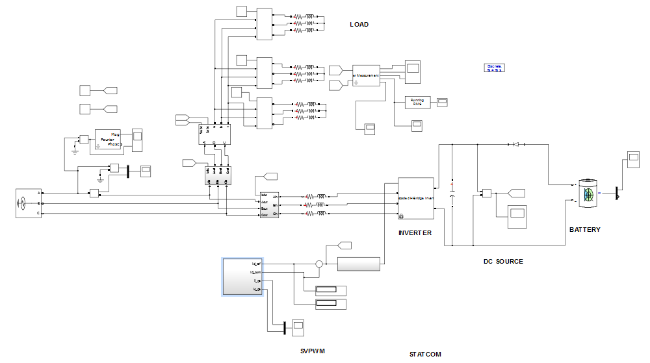

Fig. 4 Overall simulation circuit diagram

That space vector pulse width modulation has a state selector stage and switch selector stage and gating pulses are generated. This state selector stage is used to identified the which state is selected then, gating pulses is generated then, given to the cascaded h-bridge inverter switches used in the switch selector state because which switch to given the pulses to selecting process purposes. The CHB inverter voltage value is 440V, 50Hz. The inverter has taken the inputs in capacitor bank that capacitance value is 500e-6 and capacitor initial voltage is 600V. Suppose the capacitor suddenly discharged the battery bank is connected through the IGBT switch. Lead-Acid battery is used and this nominal voltage is 600V, Rated capacity is 200000Ah, and Initial state of charge is 30%.

Then CHB inverter is inverted to the voltage dc to ac voltage. Then given to the grid lines then load. The load side of the resistance and inductance is 12.218ohms and 0.038889H. The middle of the grid lines the circuit breakers used. Breakers resistance Ron is 0.001. And Snubbers resistance Rp and capacitance Cp is 1e6, infinitive. Then finally, output power is an 57.35kW totally 2.65kW power losses are occurred.

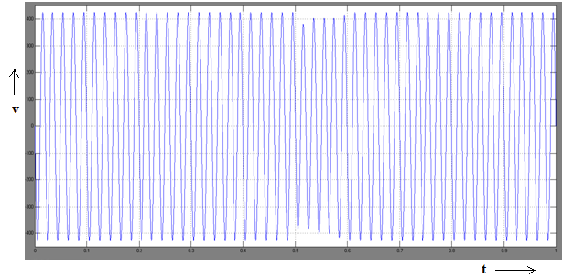

Fig. 5 Voltage Sag Waveform

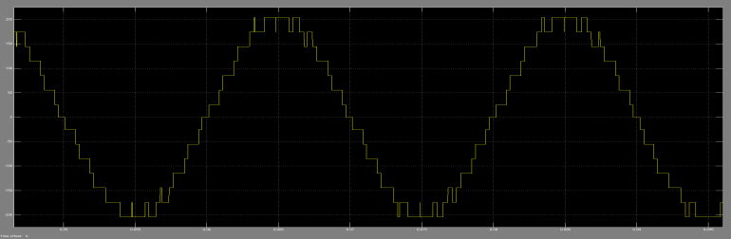

Fig. 6 15 Inverter voltage waveform

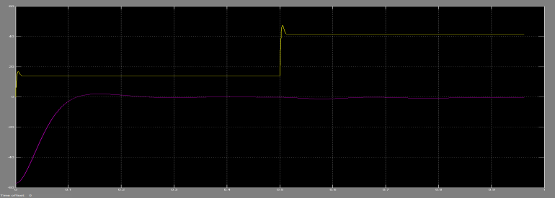

Fig. 7 Stability Graph

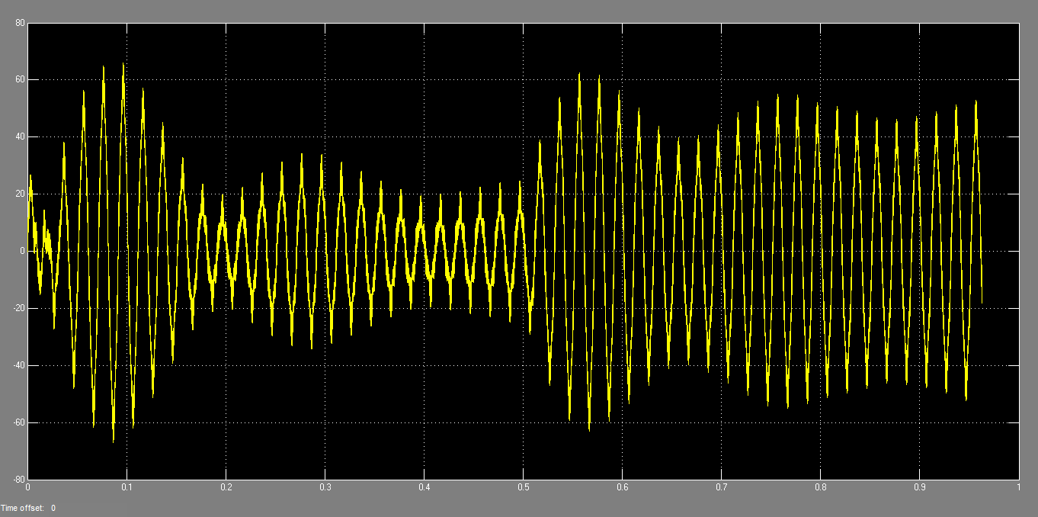

Fig. 8 STATCOM current

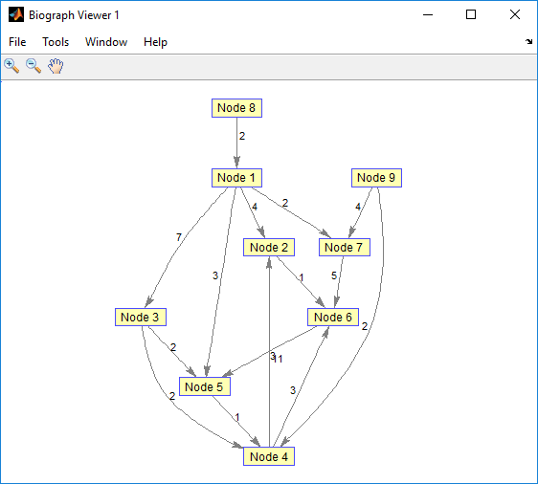

Fig. 9 Algorithm output

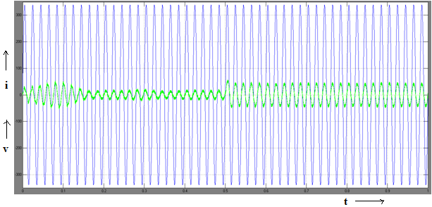

Fig. 10 Grid voltage and current waveform

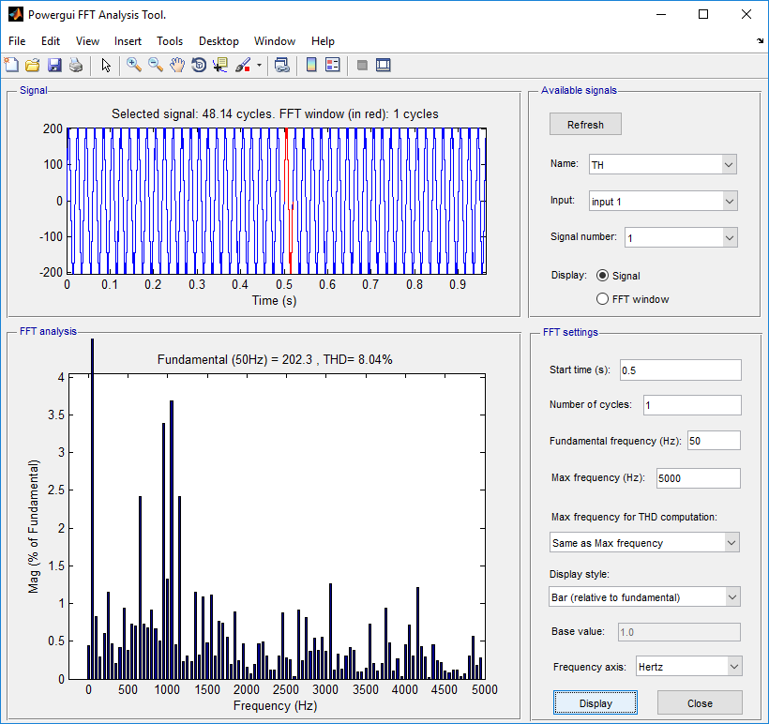

Fig. 11 THD waveform

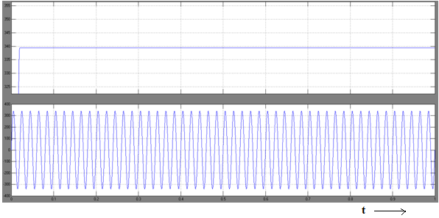

Fig. 12 Waveform of magnitude and phase angle

**TABLE I: CIRCUIT PARAMETERS VALUES**

|  |  |
| --- | --- |
| ***Quantity*** | ***Values*** |
| Phase to Phase rms voltage | 3ϕ, 415V |
| Frequency | 50Hz |
| CHB Inverter Voltage | 440V |
| Frequency | 50Hz |
| Leg Inductor | 3e-3H |
| Leg Resistance | 0.1Ω |
| Load Resistance per phase | 12.218 Ω |
| Load Inductance | 0.038889H |
| Battery nominal Voltage | 600V |

# **III. CONCLUSION**

The voltage quality is improved by cascaded h-bridge STATCOM while connecting non-linear loads. The SVPWM is best performance compared with the sinusoidal pulse width modulation technique. And Edmond’s algorithm is very efficiently performed compared with other matching algorithms. Finally, the voltage sags is compensated using MATLAB simulation link software. The system voltage drop (voltage sag) is appeared in 0.5 Seconds then the STATCOM is supplied or injected the voltages to the grid lines after the voltage sag is cleared at the time of 0.6 Seconds. And harmonics rejection also occur in this operation so, the system stability has taken time at 0.1 Seconds the system stable is 100 milliseconds. The simulation results show that, the proposed control method can make sure STATCOM precisely and quickly compensate reactive power, voltage sag and improve the power factor, stabilize the DC voltage. Finally, the unbalanced grid voltage is compensated successfully.

##### **References**

1. A.A. Edris, R. Adapa, M.H. Baker, I. Bohmann, K. Clark, K. Habashi, L. Gyugyi, J. Lemay, A.S. Mehraban, A.K. Myers, J. Reeve, F. Reeve, F. Sener, D.R. Torerson, and R.R. Wood, “Proposed terms and definitions for flexible AC transmission system (FACTS)”, IEEE Trans. Power Del., vol. 12, no. 4, pp. 1848-1853, Oct. 1997.
2. J. Dixon, L. Moran, J. Rodriguez, and R. Domke, “Reactive power compensation technologies: State-of-the-art review”, Proc. IEEE, vol. 93, no. 12, pp. 2144-2164, Dec. 2005.
3. C. Wessels, N. Hoffmann, M. Molinas, and F.W. Fuchs, “Statcom control at wind farms with fixed-speed induction generators under asymmetrical grid faults”, IEEE Trans. Ind. Electron., vol. 60, no. 7, pp. 2864-2873, Jul. 2013.
4. S. Bhattacharya, B. Fardenesh, B. Sheperling, and S. Zelingher, “Convertible static compensator: Voltage source converter based FACTS application in the New York 345kV transmission system”, in Int. Power Electronics Conf. Rec., Niigata, Japan, April. 2005.
5. V.K. Sood, HVDC and FACTS Controllers – Applications of Static Converters in Power Systems. Boston: Kluwer Academic Publishers, 2004.
6. Q. Song, W. Liu, Z. Yuan, W. Wei, and Y. Chen, “DC voltage balancing technique using multi-pulse optimal PWM for cascaded H-bridge inverters based STATCOM”, in Proc. IEEE 35th Power Electronics Specialists Conf., Aachen, Garmany, Jun. 2004, vol. 6, pp. 4768-4772.
7. J.J. Jung, S. Cui, S. Kim and S.K. Sul, “A cell capacitor energy balancing control of Modular Multilevel Converter considering the unbalanced AC grid conditions”, 2014 International Power Electronics Conference (IPEC-ECCE ASIA), Hiroshima, 2014, pp. 1268-1275.
8. D. Lu, H. Hu, Y. Xing, X. He, K. Sun and J. Yao, “Studies on the clustered voltage balancing mechanism for cascaded H-bridge STATCOM “, 2016 IEEE Applied Power Electronics Conference and Exposition (APEC), Long Beach, CA, 2016, pp. 2194-2199.
9. H.C. Chen, P.H. Wu, C.T. Lee, C.W. Wang, C.H. Yang, and P.T. Cheng, “Zero-Sequence Voltage Injection for DC Capacitor Voltage Balancing Control of the Star-Connected Cascaded H-Bridge PWM Converter Under Unbalanced Grid”, IEEE Trans. Ind. Appl., vol. 51, no. 6, pp. 4584-4594, Nov-Dec. 2015.
10. Q. Song and W. Liu, “Control of a cascade statcom with star configuration under unbalanced conditions”, IEEE Trans. Power Electron., vol. 24, no. 1, pp. 45-48, Jan. 2009.
11. N. Hatano and T. Ise, “Control scheme of cascaded h-bridge statcom using zero-sequence voltage and negative-sequence current”, IEEE Transactions on Power Del., vol. 25, no. 2, pp. 543-550, April. 2010.
12. L. Tan, S. Wang, P. Wang, Y. Li, Q. Ge, H. Ren, and P. Song, “High performance controller with effective voltage balance regulation for a cascade statcom with star configuration under unbalanced conditions”, in Proc. Of 15th European Conference on Power Electronics and Applications (EPE), Sep. 2013, pp. 1-10.
13. M. Hagiwara and H. Akagi, “Negative-sequence reactive-power control by a PWM STATCOM based on a modular multilevel cascade converter (MMCC-SDBC)”, IEEE Trans. Ind. Appl., vol. 48, no. 2, pp. 720-729, Mar. 2012.